Banknotes (Paper Money)
# Source: AI Source: Provided by: [Data Path: Persons Table -> ID Column: 1, Name_En Column: Motasem Essam] -> From: [ChatGPT] on [7/17/2026]
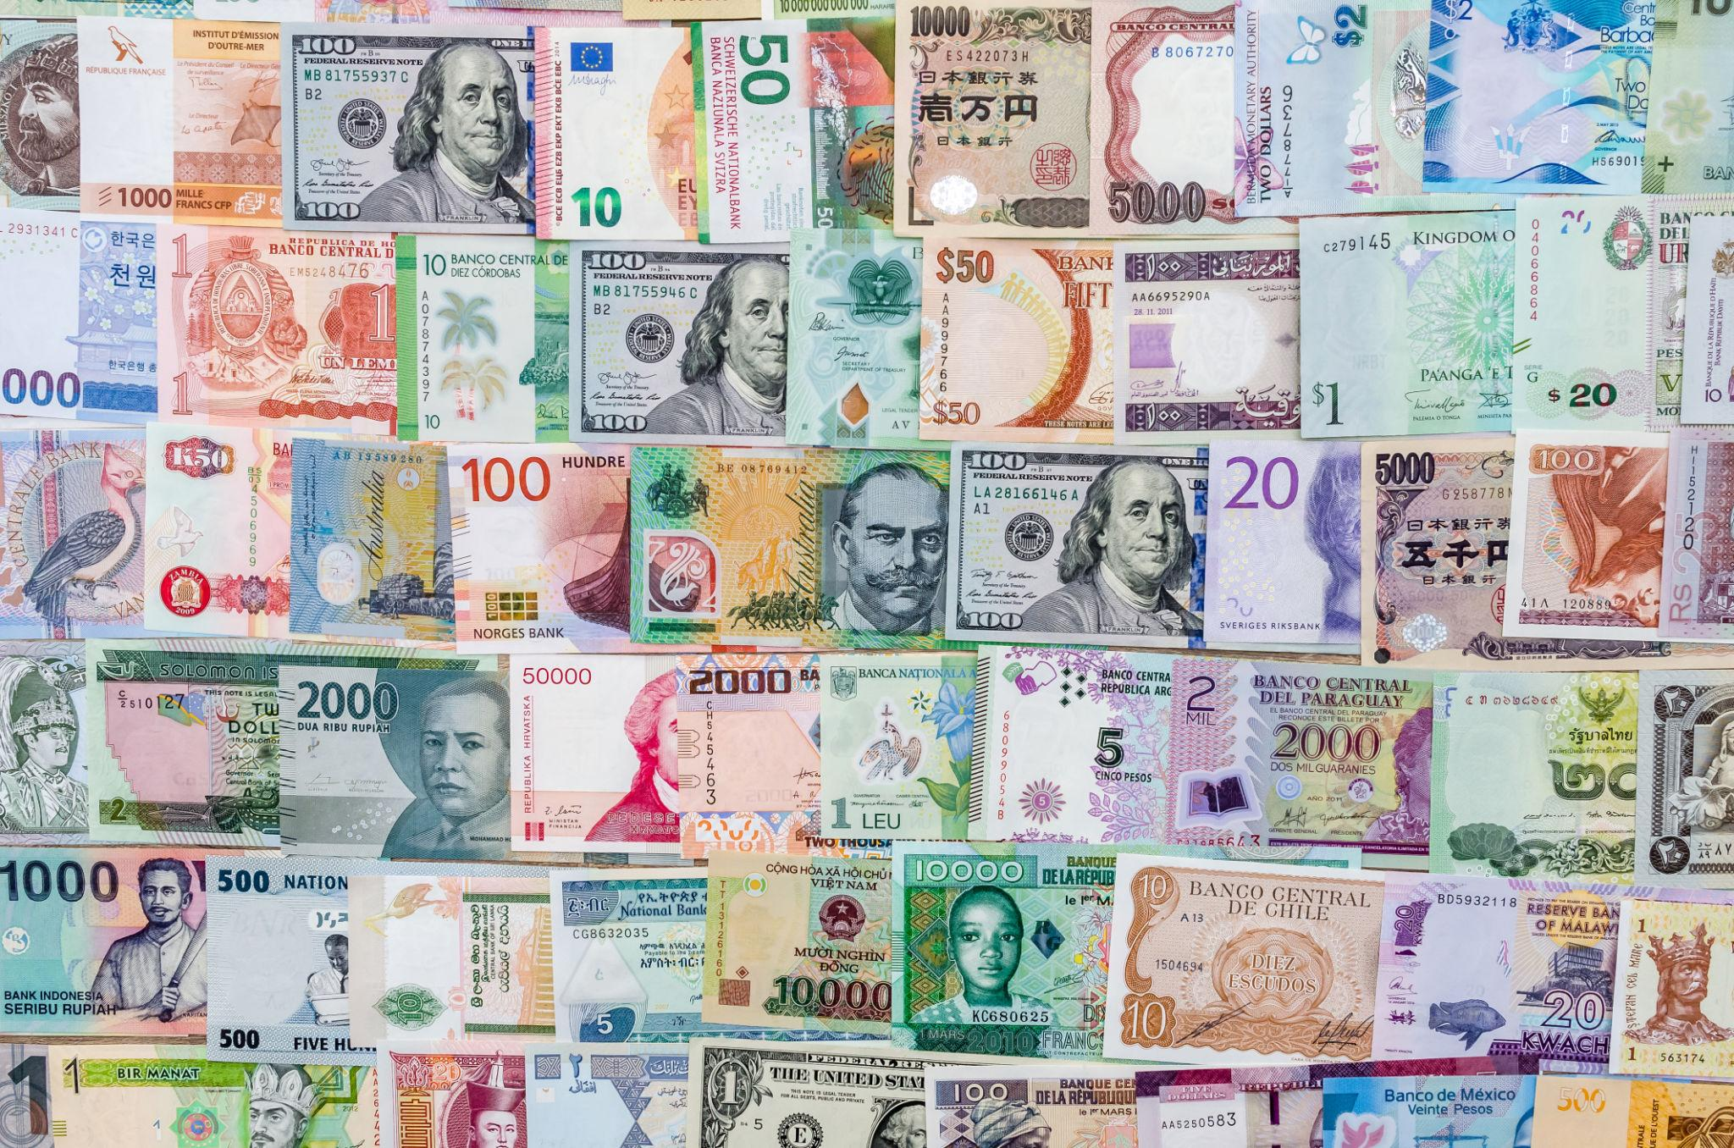
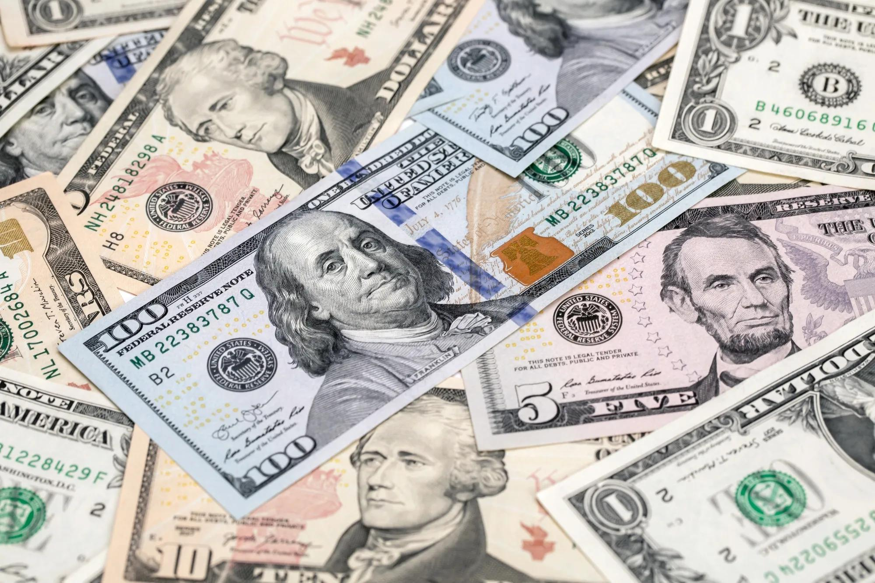
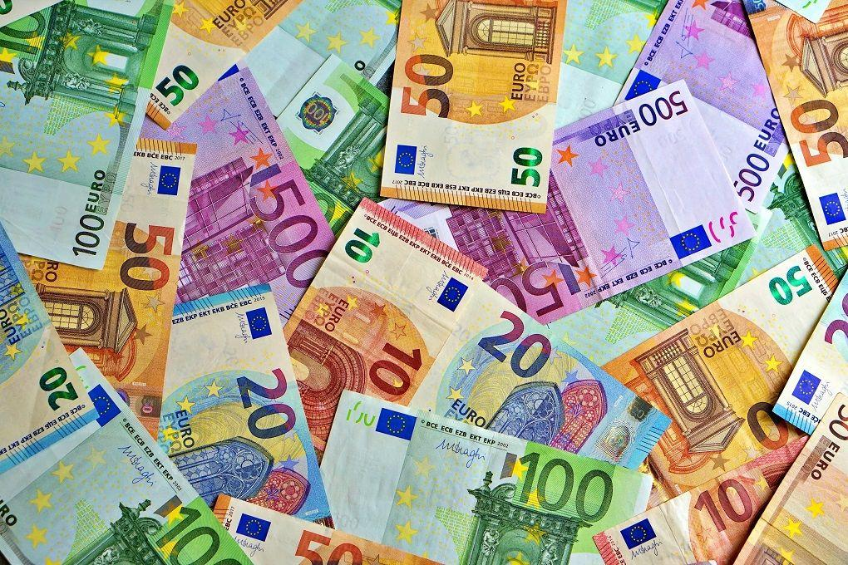
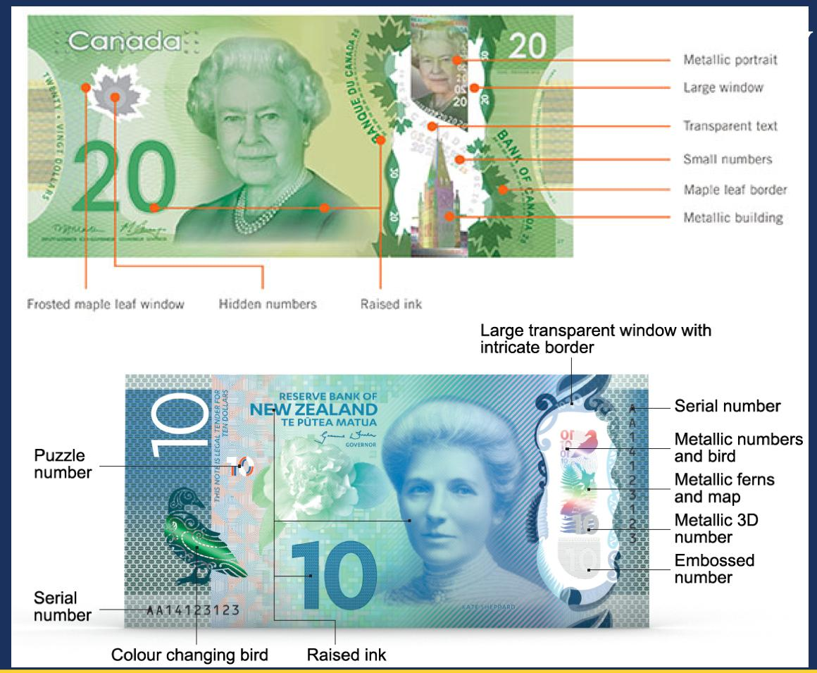
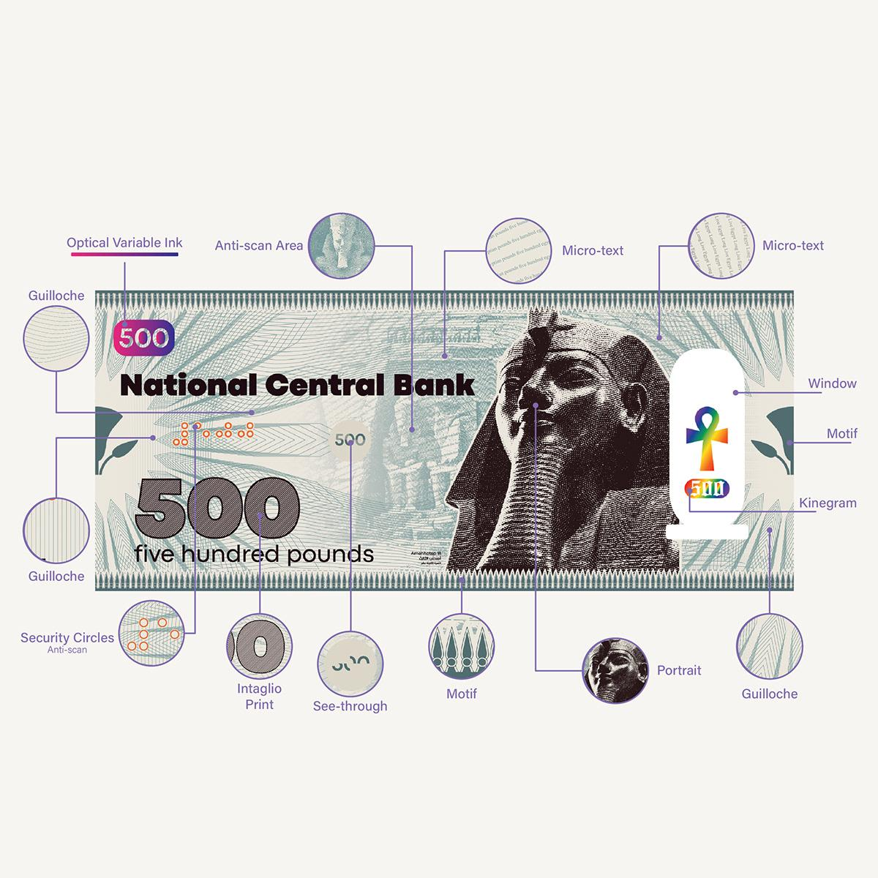
Banknotes, commonly called paper money, are printed or polymer-based forms of currency issued by a government or central bank. They represent a specific monetary value and are widely used for medium- and high-value transactions. Like coins, banknotes are legal tender within the country or region that issues them.

Definition
# Source: AI Source: Provided by: [Data Path: Persons Table -> ID Column: 1, Name_En Column: Motasem Essam] -> From: [ChatGPT] on [7/17/2026]
A Banknote is an officially issued piece of paper or polymer currency that represents a fixed monetary value and is used as legal tender for making payments and measuring economic value.

Purpose
# Source: AI Source: Provided by: [Data Path: Persons Table -> ID Column: 1, Name_En Column: Motasem Essam] -> From: [ChatGPT] on [7/17/2026]
Banknotes are used to:
- Purchase goods and services.
- Carry larger amounts of money more conveniently than coins.
- Store and transfer monetary value.
- Facilitate everyday financial transactions.

Characteristics of Banknotes
# Source: AI Source: Provided by: [Data Path: Persons Table -> ID Column: 1, Name_En Column: Motasem Essam] -> From: [ChatGPT] on [7/17/2026]
Banknotes typically have the following characteristics:
- Issued by a central bank or government.
- Printed with a fixed denomination (face value).
- Made from specialized paper or polymer.
- Contain advanced security features to prevent counterfeiting.
- Recognized as legal tender.

Parts of a Banknote
# Source: AI Source: Provided by: [Data Path: Persons Table -> ID Column: 1, Name_En Column: Motasem Essam] -> From: [ChatGPT] on [7/17/2026]
A banknote usually includes:
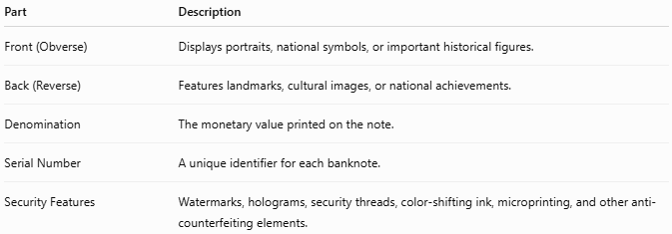
Part | Description
Front (Obverse) | Displays portraits, national symbols, or important historical figures.
Back (Reverse) | Features landmarks, cultural images, or national achievements.
Denomination | The monetary value printed on the note.
Serial Number | A unique identifier for each banknote.
Security Features | Watermarks, holograms, security threads, color-shifting ink, microprinting, and other anti-counterfeiting elements.

Materials Used
# Source: AI Source: Provided by: [Data Path: Persons Table -> ID Column: 1, Name_En Column: Motasem Essam] -> From: [ChatGPT] on [7/17/2026]
Modern banknotes are commonly made from:
1. Cotton-Based Paper
Used by many countries because it is durable and resistant to wear.
2. Polymer
Plastic-based material that:
- Lasts longer.
- Resists water and dirt.
- Provides improved security.
Examples include banknotes used in countries such as Australia, Canada, and the United Kingdom.

Examples
# Source: AI Source: Provided by: [Data Path: Persons Table -> ID Column: 1, Name_En Column: Motasem Essam] -> From: [ChatGPT] on [7/17/2026]
Banknotes represent the major units of a currency.
Examples:
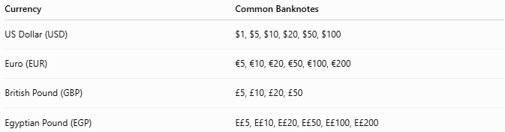
Currency | Common Banknotes
US Dollar (USD) | $1, $5, $10, $20, $50, $100
Euro (EUR) | €5, €10, €20, €50, €100, €200
British Pound (GBP) | £5, £10, £20, £50
Egyptian Pound (EGP) | E£5, E£10, E£20, E£50, E£100, E£200

Legal Tender
# Source: AI Source: Provided by: [Data Path: Persons Table -> ID Column: 1, Name_En Column: Motasem Essam] -> From: [ChatGPT] on [7/17/2026]
Officially issued banknotes are considered legal tender, meaning they are accepted for settling debts and making payments according to the laws of the issuing country.

Security Features
# Source: AI Source: Provided by: [Data Path: Persons Table -> ID Column: 1, Name_En Column: Motasem Essam] -> From: [ChatGPT] on [7/17/2026]
Modern banknotes include several anti-counterfeiting measures, such as:
- Watermarks
- Security threads
- Holograms
- Microprinting
- Color-shifting ink
- Raised (intaglio) printing
- Transparent windows (polymer notes)
- Ultraviolet (UV) features
These features help verify authenticity and discourage forgery.

Advantages
# Source: AI Source: Provided by: [Data Path: Persons Table -> ID Column: 1, Name_En Column: Motasem Essam] -> From: [ChatGPT] on [7/17/2026]
Banknotes:
- Are lightweight and easy to carry.
- Suitable for larger transactions than coins.
- Easy to store in wallets and cash registers.
- Include advanced security features.
- Widely accepted for everyday use.

Limitations
# Source: AI Source: Provided by: [Data Path: Persons Table -> ID Column: 1, Name_En Column: Motasem Essam] -> From: [ChatGPT] on [7/17/2026]
Banknotes:
- Can become worn or damaged through use.
- Paper notes may tear or absorb moisture.
- Can be lost or stolen.
- May require periodic replacement.

Applications
# Source: AI Source: Provided by: [Data Path: Persons Table -> ID Column: 1, Name_En Column: Motasem Essam] -> From: [ChatGPT] on [7/17/2026]
Banknotes are commonly used in:
- Retail purchases
- Banking
- Salaries and wages
- Cash withdrawals
- Business transactions
- Personal savings

Historical Importance
# Source: AI Source: Provided by: [Data Path: Persons Table -> ID Column: 1, Name_En Column: Motasem Essam] -> From: [ChatGPT] on [7/17/2026]
Paper money was first developed in China during the Tang Dynasty (7th–10th centuries) and became more widely used during the Song Dynasty (10th–13th centuries). Over time, many countries adopted banknotes because they were more practical than carrying large quantities of metal coins.

Common Mistakes
# Source: AI Source: Provided by: [Data Path: Persons Table -> ID Column: 1, Name_En Column: Motasem Essam] -> From: [ChatGPT] on [7/17/2026]
- Assuming a banknote's face value is determined by the cost of the paper or polymer (its value comes from the issuing authority and public trust).
- Confusing banknotes with checks or other financial documents.
- Believing damaged banknotes always lose their value (many central banks allow qualifying damaged notes to be exchanged).

Interesting Facts
# Source: AI Source: Provided by: [Data Path: Persons Table -> ID Column: 1, Name_En Column: Motasem Essam] -> From: [ChatGPT] on [7/17/2026]
- Many countries have switched from paper to polymer banknotes because they are more durable and secure.
- Modern banknotes often feature famous historical figures, cultural heritage, or national landmarks.
- High-denomination banknotes are generally used less frequently in everyday purchases than lower denominations.

Comparison with Coins
# Source: AI Source: Provided by: [Data Path: Persons Table -> ID Column: 1, Name_En Column: Motasem Essam] -> From: [ChatGPT] on [7/17/2026]
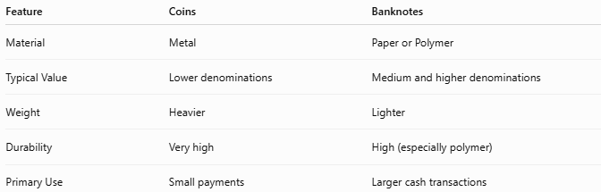
Feature | Coins | Banknotes
Material | Metal | Paper or Polymer
Typical Value | Lower denominations | Medium and higher denominations
Weight | Heavier | Lighter
Durability | Very high | High (especially polymer)
Primary Use | Small payments | Larger cash transactions

Key Points
# Source: AI Source: Provided by: [Data Path: Persons Table -> ID Column: 1, Name_En Column: Motasem Essam] -> From: [ChatGPT] on [7/17/2026]
- Banknotes are paper or polymer forms of money.
- They are issued by governments or central banks.
- Banknotes represent fixed monetary values.
- They contain advanced security features to prevent counterfeiting.
- Official banknotes are legal tender.
- Banknotes are widely used for everyday and larger-value transactions.

Conclusion
# Source: AI Source: Provided by: [Data Path: Persons Table -> ID Column: 1, Name_En Column: Motasem Essam] -> From: [ChatGPT] on [7/17/2026]
Banknotes (Paper Money) are official forms of currency issued by governments or central banks to represent monetary value. Lightweight, portable, and equipped with sophisticated security features, they provide an efficient means of carrying and exchanging money for everyday and higher-value transactions. Although digital payments are becoming increasingly common, banknotes continue to play a vital role in global economies as a trusted and widely accepted form of legal tender.

